SELECT with various clause – WHERE, pattern matching
Out Put:
1.
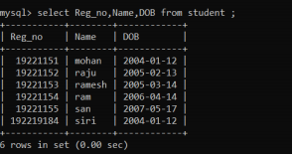
2.
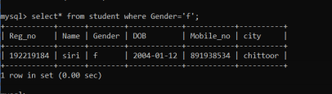
3.
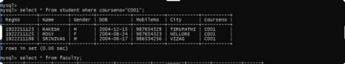
4.
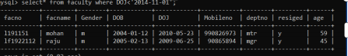
5.
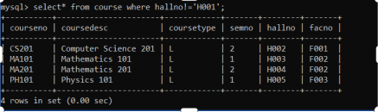
6.
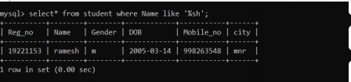
7.
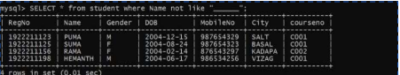
8.
